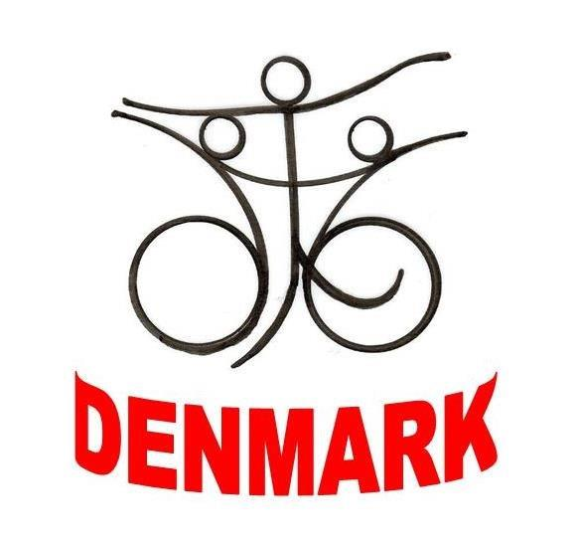
Danish Wheelchair
dance cup 2023

Dear friends of wheelchair dancing
After a successful second Danish Wheelchair Dance Cup in 2019, the Danish Wheelchair Dance, are happy to invite you to the third Danish Wheelchair Dance Cup 2023.
Sunday 27th of May 2023 see paper with categories
Saturday 28th of May 2023 see paper with categories
The Danish Wheelchair Dance Cup will be hell at Musholm Holiday - Sport - Conference as last time - see paper for accommodation details. If you need transportation from and to the airport, it will be at an extra cost of € 50 each way per person, which must be paid directly to the organizers. There is appr. 113 km/1h+10 min each way. OR you can take a train from Copenhagen airport to Korsør Train station cost 23€ each way, and we will pick you up at Korsør for free
Should there be any questions, or problems, please don’t hesitate to write or phone us.
We are looking forward to seeing you
Happy dancing!

From Danish Wheelchair Dance Karina Frederiksen , Jannie Christiansen, Johnny Pedersen Phone: 0045 40116717

